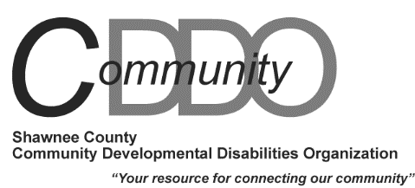

TARC 2701 SW Randolph Ave Topeka KS 66611
(785) 232-0597 Fax (785) 232-3770 www.tarcinc.org
Memo from the Human Resources Division

DATE: October 22, 2019

TO: Support Staff

FROM: Chris Noe, Executive Assistant 785-506-8652

RE: Job posting for CDDO Assessor

POSTING DATES: October 22, 2019 - until filled
CDDO Assessor

The Shawnee County CDDO is currently seeking a responsible person to facilitate annual assessment meetings for individuals who have been determined eligible for Intellectual/ Developmental Disability (I/DD) services.

The CDDO Assessor will be responsible for conducting assessments to determine Home and Community Based Services (HCBS) I/DD waiver eligibility for individuals receiving Intellectual and Developmental Disability services and supports in Shawnee County. Work in collaboration with team members to provide support and resource identification to persons eligible for services.

- Bachelor’s Degree in human service-related field and six (6) months full-time experience in the I/DD field preferred or additional full-time experience in the field of I/DD services, which may be substituted for the degree at the rate of six (6) months of full-time experience for each missing semester of college.
- Must have and maintain a valid Kansas Driver’s License as well as a satisfactory driving record.
- TARC conducts background screenings as well as post offer, pre-employment and random drug testing.

Make application/send resume to: TARC Human Resources, TARC, 2701 SW Randolph Ave,
Topeka, KS 66611 or e-mail to cnoe@tarcinc.org E.O.E.

Salary Level: 7
Posting Locations: TARC; TARC Website; kansasworks.com Indeed.com, Washburn

