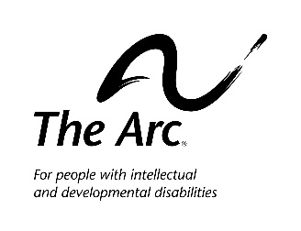
The Arc of Sedgwick County is looking for a dynamic Program Director to lead some of the most exciting and well-established programs serving individuals with intellectual/developmental disabilities in the State of Kansas.

This is a full-time, salaried exempt position and serves on the management team of The Arc. The Program Director is responsible for The Arc’s Special Projects Department and all programs and events connected to this department. The Program Director ensures dependable, safe and appropriate programming for those The Arc serves. The Program Director is heavily involved in fund-raising activities as they relate to special events.

Candidates MUST have the following knowledge, skills and abilities:
- Professional, independent self-starter who takes on responsibility and has excellent attention to details
- Strong organizational and multi-tasking skills
- Effective oral and written communication skills
- Basic knowledge of Microsoft Office, including Outlook, Word, Excel and Access
- Valid Commercial driver’s license (CDL) or ability and willingness to obtain a CDL within 2 months of hire
- Bachelors’ degree in a Human Services or related field. (Five years of successful work experience in a related field may qualify as a substitution for a portion of the education requirement.)
- Experience in program development and minimum of five years of leadership experience
- To perform this job successfully, an individual MUST have successful experience serving people with developmental/developmental disabilities.

Key areas of responsibility include:
- Developing, sustaining, growing and evaluating programs to meet the mission of The Arc
- Directly providing care and support for those with developmental disabilities within programs
- Developing and ensuring program budgets are met
- Hiring and training program staff and volunteers
- Overseeing program resources including, but not limited to vehicles, equipment and supplies
- Assisting with community awareness education and training activities
- Participating with development & marketing activities supporting The Arc programs

Qualified applicants should send your resume and a cover letter to The Arc of Sedgwick County, c/o Executive Director, 2919 West Second St, Wichita KS 67203 by November 25, 2019

To learn more about The Arc, visit: www.Arc-SedgwickCounty.org

